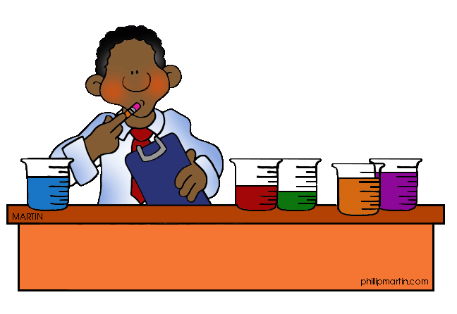
The Steps of the
Scientific Method

- Observation: Scientists observe the world around them and asked questions based on the observations they made.
- Question: A question is formed from facts and observations.
- Research: Scientists gather information about the topic in order to make an educated guess about what will happen.
- Hypothesis: Scientists make an “If….then…” statement that can be tested to answer the question.
- Experiment: An experiment is a procedure that is carried out and repeated under controlled conditions in order to discover, or test, a hypothesis.
- Results/Data: In an experiment a scientist must observe carefully, using all five senses, to collect accurate and reliable data. The data is then analyzed.
- Conclusion: A conclusion is a statement about whether or not a hypothesis is valid, or supported by the evidence. Sometimes the data does not support the hypothesis, and it is determined that different methods or observations are needed.

Science Experiment Name ______________________
Write – Up Date ______________________

Question: __________________________________________________________

___________________________________________________________________

Hypothesis: ________________________________________________________

___________________________________________________________________

Materials: Diapers, water, cups and containers, paper towels

Procedure: _________________________________________________________

___________________________________________________________________

___________________________________________________________________

___________________________________________________________________

___________________________________________________________________

___________________________________________________________________

___________________________________________________________________

___________________________________________________________________

Observations/Data: Record all your data in your science notebooks.

*Describe everything you see, smell, hear, taste, and touch throughout the entire experiment. Be sure to be as accurate and detailed as possible.
*Keep this question in mind…How do you know that your results are reliable?
Diaper Data
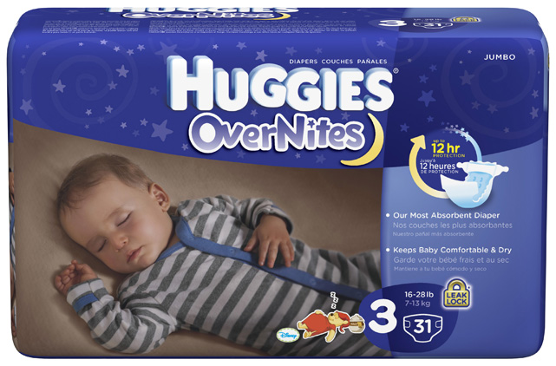
Night-time sometimes calls for a different level of protection, and HUGGIES® Overnites Diapers are our most absorbent diaper. It's a simple way to give everybody sweet dreams.
- Our most absorbent diaper to help keep baby comfortable and dry
- Up to 12 hours of protection against leaks
- The SnugFit* waistband helps the diaper stay in place throughout the night
- Unique tabs for a secure fit
Adorable graphics, featuring Sleepy Winnie the Pooh Disney designs
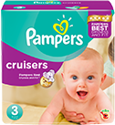
- Pampers Best Protection and Fit
- 3-Way Fit contours to baby's waist, legs, and bottom
- Specially designed to fit better than Pampers Baby Dry,® with less bulk and a closer fit to baby's bottom
- Stretchy sides help the diaper stay in place, flexing with baby's every move
- Up to 12 hours of protection (sizes 3–5)
Fun Sesame Street® designs

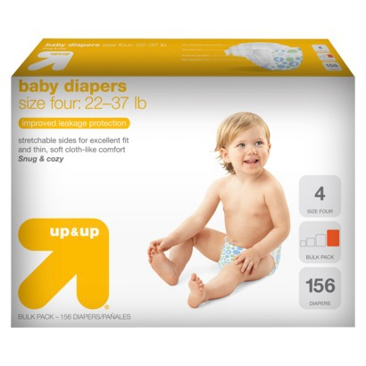
These up & up diapers are now thinner, softer, stronger and cuter than ever. The soft, hypoallergenic lining will keep your baby dry and comfortable. The soft stretchable sides and ultra-soft back sheet make this one comfy diaper.
- Includes: Diapers
- Diaper Size: 4
- Features: Elastic Stretch Sides, Contoured Shape, Hypoallergenic, Hook and Loop Fastener
- Material: Wood Fluff Pulp
Health Facts: Chlorine-Free, Latex-Free, Perfume-Free

