- Give two examples of how Native American tribes honored nature.

- Why do you think Native Americans considered nature to be so sacred?

- Do you believe our culture shares the Native American view of nature? Give two reasons or examples that show why or why not.

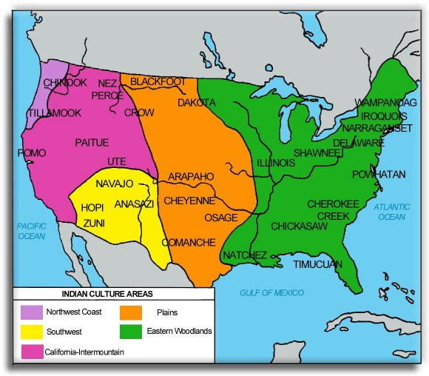

Just used for reference during my instruction as to what to color on the front cover (map) . Don’t copy.

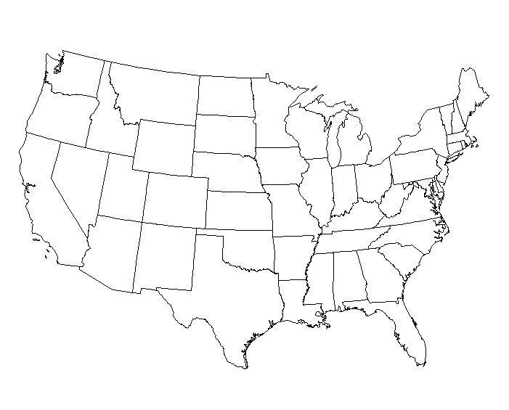

Daily Life
Natural Resources
Climate
Geography

